@CHECK – A MODERN CLASS ATTENDANCE CHECKING TOOL

Jassem Krzysztof1, Paliwoda Joanna1, Wierzbiński Bartłomiej1

1Adam Mickiewicz University (POLAND)

Abstract

Students’ attendance at university classes can be checked in several ways. The old-school approach – with students signing the attendance list – disorganizes the course of the lecture while typing the attendance list into any type of electronic diary requires extra time from the teacher. Taking attendance orally during class is, in turn, not only time-consuming, but it is also hardly feasible in large groups of students.

Client-server solutions might streamline the process. Students could connect to the server using their mobile devices or laptops to confirm their attendance. This procedure, however, requires that they always bring their devices to class. Moreover, additional measures would have to be taken to prevent access to the system from outside the classroom.

Attendance could also be checked by means of dedicated chip card readers – resembling those used in offices which register employees’ working time by storing their clock-in and clock-out times. This technology, however, is relatively costly and requires that students always carry an additional card.

The system developed by a group of students from FMCS (Faculty of Mathematics and Computer Science), Adam Mickiewicz University, Poznań, Poland, is a solution to all of the abovementioned problems. Its users confirm their attendance by means of their standard student cards. As a result, no additional devices are required since the chips on the student cards applied at FMCS are processed using cheap extensions to standard keyboards already in place at the Faculty.

The @CHECK system also offers a number of additional functionalities. In the “seating mode”, for example, after having their card read the student can select the seat they would like to take (in the same way one chooses a seat in the cinema). Information on the seating of the students is also available to the teacher, who can see it on his or her computer screen, as a result of which students are no longer anonymous to the lecturer. Moreover, since this information is permanently stored in a database, the teacher can also compare solutions and answers worked out by students sitting next to each other to prevent mutual copying.

In the “no-seating mode”, students do not select the seats they would like to take, which substantially shortens the time necessary to check attendance. In the “automatic seating mode”, the system assigns seats to students randomly, which may be useful during tests and examinations. The teacher may also want to apply this mode to make sure that students do not always collaborate in identical teams while working on consecutive tasks.

@CHECK has been successfully tested during a lecture attended by 48 students, and at the moment (March 2020) it is being deployed at FMCS to be tested during 10 courses starting in the summer term of 2020.

One of the most important features of the solution is its scalability. The module processing student cards can be easily extended to support any type of chip. As a matter of fact, three different types of student cards are currently in use at FMCS (depending on the date of issue) and all of them are successfully processed by the system.

Keywords: Attendance checking, chip cards, innovative technology

# INTRODUCTION

Checking students’ attendance at a university may serve several goals. First of all, some classes are obligatory for students – attendance is a mandatory condition for getting a pass in the course. The attendance check is sometimes taken at non-obligatory lectures, when systematic students are given opportunities to achieve credit points. Attendance data lets teachers analyze statistics in order to find more attractive ways to increase student presence in the future.

The paper presents a convenient solution for the attendance check at a university class, which may satisfy various teachers’ expectations. The paper is structured as follows: In Section 2 we present existing methods for attendance check used at universities. Section 3 discusses solutions used in companies to track employees attendance, as well as potential applicability of these solutions for educational needs[1]. In Section 4 we describe our application, which has been implemented at FMCS, in the co-operation of computer science students and their teachers. In Section 5 we describe experiments with testing and deploying the system. We conclude our work, by pointing out the system’s advantages in Section 6.

# METHODS for Attendance Check used in HIGH education

## The verbal check

The verbal old-school method of attendance check is probably the most commonly used at schools of any type. It consists in the teacher calling the student’s name and ticking the attendance/absence in a diary. The method consumes time during the class, takes additional teacher’s time at the end of the term to create students attendance records, and is prone to various kinds of mistakes and errors.

## Class attendance sheet

This method is characteristic of high education. The teachers prepares a separate attendance sheet for a class and the students sign their names. When the class is over, the teacher usually writes down the attendance in a teacher’s paper notebook or a spreadsheet. The method consumes less time during the lecture than the verbal check, as the sheet usually circulates around the students. However, the method takes more teacher’s time between classes. The other downside is that the student may sign in their absent colleagues.

## On-line check

The attendance at on-line courses may be checked using the dedicated software. An example is the MyAT [2] service, which allows teachers to check the attendance at on-line courses on a device of their choice. The software landing page describes the solution in the following way: “Once you have entered or imported your list of students and classes, taking attendance for each of them is as simple as selecting the class and tapping on each student in the list from any device anywhere.”

The Microsoft Teams platform has gained popularity as the educational tool during the Covid-19 epidemy. The users are highly interested in the functionality of attendance check. The question: “How to Record Attendance in Microsoft Teams” asked to Microsoft Community had 176 “followers” (users who clicked “I have the same question” button) on the 26th of April 2020. Figure 1. presents the answer from the Microsoft engineer (the screenshot comes from [3]).

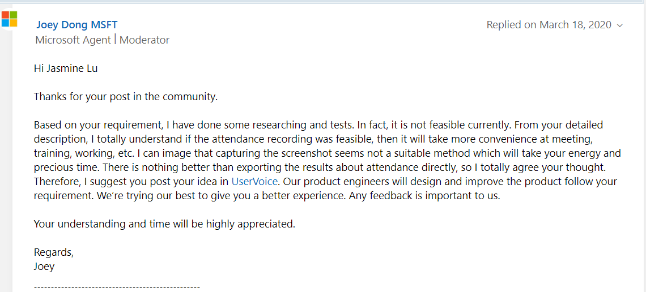

Figure 1. On-line check in Microsoft Teams

It turns out, however, that there exists a possibility of incorporating the attendance check to the software. Ms Teams allows for the development of additional plugins. Such a plugin – for the attendance check has been ordered by Adam Mickiewicz University (AMU). An AMU teacher can now add a new card to the MS Teams menu, as shown in Figure 2.



Figure 2. Adding a new card in MS Teams

A teacher may select a special card called “Panel listy obecności” (“Attendance list panel”), and then use it at the class (Figure 3).



Figure 3. Attendance list panel in MS Teams

The attendance may be checked in two ways. The teacher may tick a checkbox for each student present at the class (potentially confirming the attendance by vocal contact) or a teacher may generate a password that is visible for students for a selected period of time and allow the students to confirm their attendance independently, provided they know the password. The attendance at each class is recorded in the MS-Excel sheet.

The online check is less time-consuming than previous methods (even in the scenario of vocal confirmation the teacher’s does not waste time for copying the attendance to a notepad or a spreadsheet). The password feature impedes the absent students from signing in but this safety measure is easy to break (the password may be immediately sent to an absent student by a colleague).

## Attendance apps for students

This method involves tracking software installed by students at their mobile devices. Students confirm their attendance by means of the application connected to the server that gathers the information. This procedure, however, requires the students to bring their devices to classes. Moreover, additional safety measures (such as temporarily visible passwords) need to be taken to prevent access to the system from outside the classroom.

The downsides of all above-mentioned solutions incline university teachers to look for the solutions applied in companies.

# Methods for attendance check at companies

## Entering time in a spreadsheet

The employee marks his working hours in a spreadsheet. The method may be realized in two scenarios: the working hours are entered by a doorman or any other person designated for the task or the employees mark the working hours on their own. The first scenario is unrealistic to be applied in education. The other scenario would unable teachers to control the attendance.

## Mobile attendance system

Mobile systems (based on GPS) enable workers to mark their attendance at the location required by employer. The employee confirms their presence at work by just logging in at any place they currently stay. Such a solution could be applied for on-line teaching, although the situation that the teacher requires the students to stay at the required location during classes does not seem to occur frequently.

## Employee attendance app

In this method an employee enters their working hours in the application. This makes it possible to check the attendance data both for employers and the employees. The employer, however, has little control on the employee, who can enter the start of their work from any location. Similar solutions are used in on-line education – see Section 2.3 for examples. They share the same downside – lack of control over students’ real attendance.

## Coded access

In this method the employee’s identity is verified during entry and exit. The entry/exit times are automatically converted into working ours and stored in the database. There exist several technical solutions for this method. The employees may be identified by a unique code they have to type in before the access is given, they may be automatically recognized by their fingerprints or faces, etc. All these solutions are expensive. If used for the attendance check at universities, the methods would not be welcome by students as they infringe students’ privacy.

## Card swipe system

Card swipe systems are very popular in offices. The employee must swipe the card in order to get into the office, as well as to leave it. Some employers require the use of the swipe card on the entering to the employee’s working room (to calculate the effective working time by deducing the rest time spent e.g. in the canteen). The attendance data is used for payroll and other documentation. Applied for the education, the solution would be costly, as the teachers would expect the students to swipe the cards on entering to the classroom rather than to the university building.

# @CHECK – the attendance check system using student cards

@CHECK is the application developed by a group of MSc students from FMCS in the winter semester 2019/2020, in the co-operation of their teachers, who expressed their expectations towards the system.

The system users confirm their attendance by means of their standard student cards. No additional devices are required since student cards applied at FMCS are read by cheap extensions to standard keyboards already in place at the Faculty.

The architecture of the system is client-server. The server keeps track of the attendances and stores them in the database. The client application intended for the student verifies attendance and selects their seatings. The client application intended for the teacher plans the course, visualizes the students’ seatings and returns attendance statistics.

## Planning the course

At the beginning of the term the teacher adds plans of their courses. For each course the teacher types in its name, day of the week, starting time, and the name (id) of the classroom. By default, the system assumes that the classes are held regularly on the weekly basis in the same classroom. Once the course has been planned, the system is ready for students’ registration at all scheduled dates in the term.

## Starting the check

The teacher starts the attendance check at the time of their choice. If the checking time coincides with the time scheduled for one of the courses, the teacher does not have to type in the information on the course once more. On starting the check the teacher chooses the *attendance mode*. The *seating mode* (see. 4.3.1.) is selected by default.

## Checking the attendance

On entering the classroom a student approaches the designated computer with the @CHECK client installed (it may be the same computer as intended for displaying the teacher’s presentation). The computer should be connected to the card-reading device. At FMCS the reading devices are embedded into standard keyboards. Their cost is not higher than 10€ per item.

The student swipes their card in the reading device. The confirmation of the student’s name appears in the computer screen. In the unlikely event that the student card is not read properly or the student is not at the possession of their card, the student’s index number may be typed in instead – with the same effect as swiping the card.

The next action of the system depends on the attendance mode selected by the teacher for the class.

### Seating mode

In the “seating mode” after having their card read the student can select the seat they would like to take (in the same way one chooses a seat in the cinema). This is shown in Figure 4.

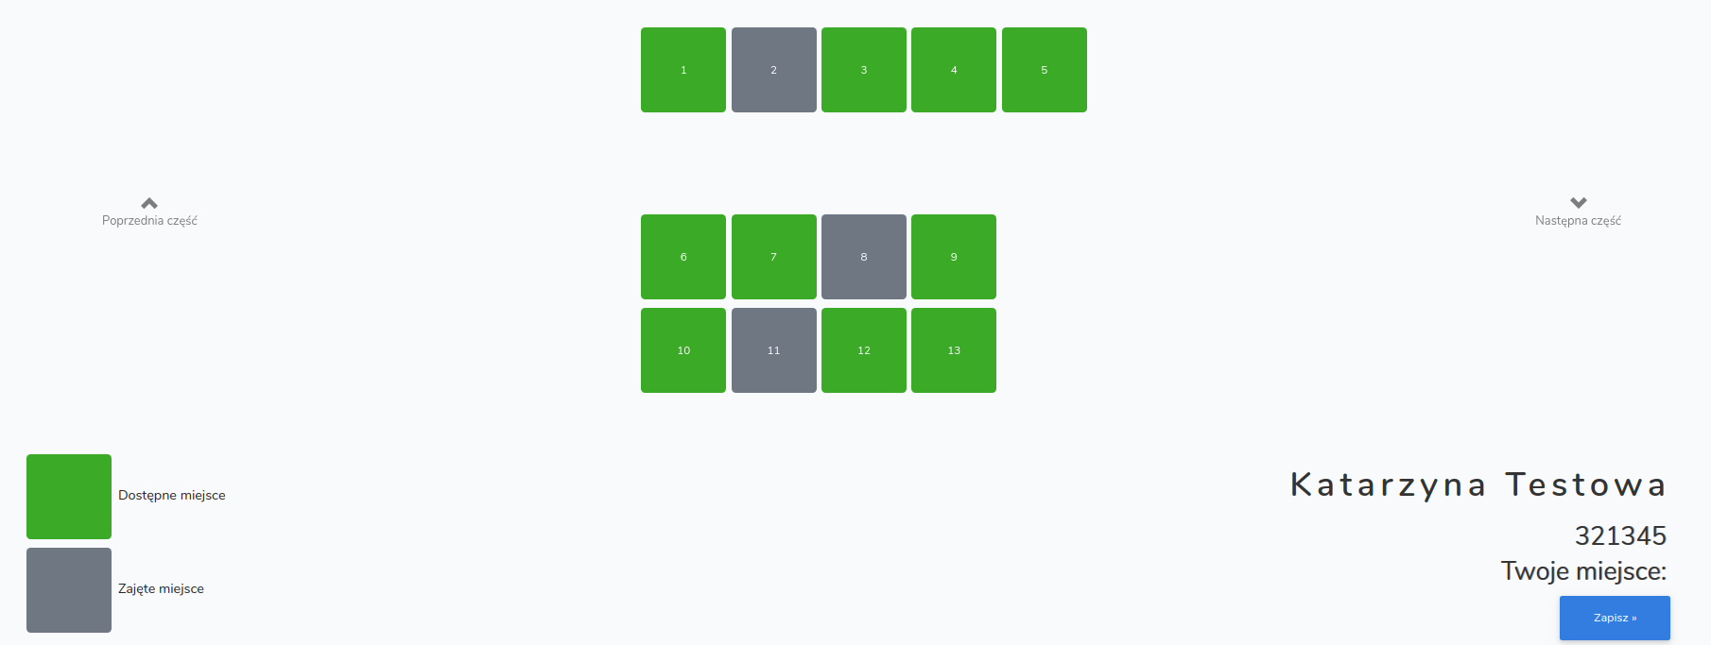

Figure 4. Selecting a seat

The system displays the setting of seats characteristic for the classroom. Figure 4 presents the computer laboratory with 13 available seats located in three rows. At the moment shown in Figure 4, three seats are already taken and the student has the choice among the 10 remaining ones.

### No-seating mode

In the “no-seating mode”, students do not select the seats they would like to take, which substantially shortens the time necessary to check attendance. This feature is particularly helpful during lectures presented to large groups of students.

### Automatic mode

In the “automatic mode” (Figure 5), the system assigns seats to students randomly, which may be useful during tests and examinations. The teacher may also want to apply this mode to make sure that students do not always collaborate in identical teams while working on consecutive tasks.

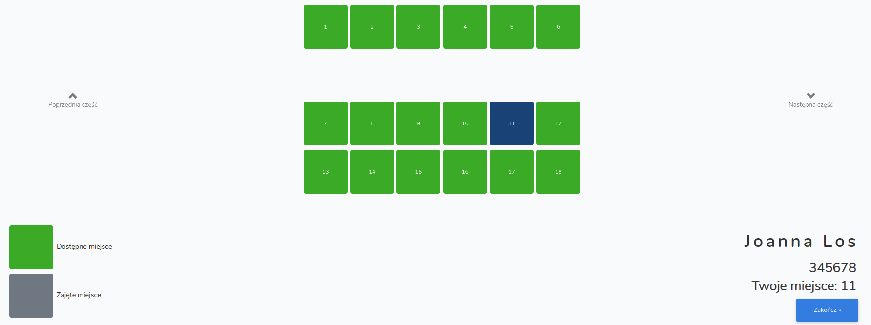

Figure 5. Automatic seating mode

Figure 5 shows how the student, having checked the attendance, is suggested the seat selected randomly by the system.

## Viewing the classroom

Information on the seating of the students is available to the teacher (Figure 6), who can see it in the computer screen, as a result of which students are no longer anonymous to the lecturer.

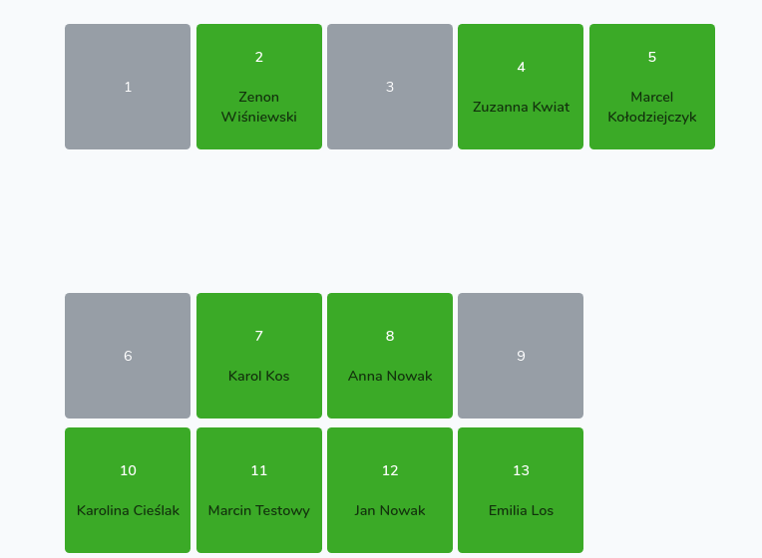

Figure 6. View of the classroom from the teacher's perspective[2]

The teacher may wish to see the present students in the form of a sorted list (Figure 7). The teacher can select a student from the list and add a note, e.g. on student’s activity or delay (in Figure 7, the teacher noted that the student named Kacper Kot was 10 minutes late for the class.)

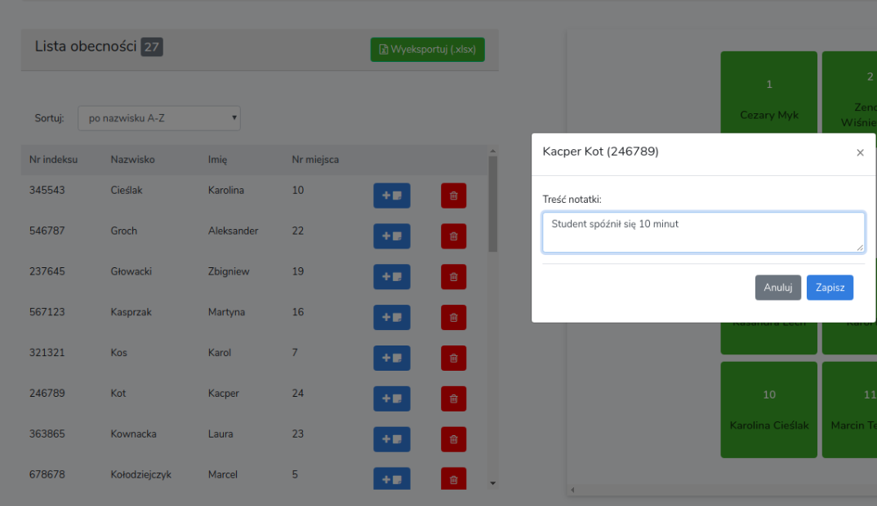

Figure 7. Adding a note on student's activity

## Keeping track of the attendance

The information on the attendance as well as on the seating of the students, may be saved into the spreadsheet (Figure 8).

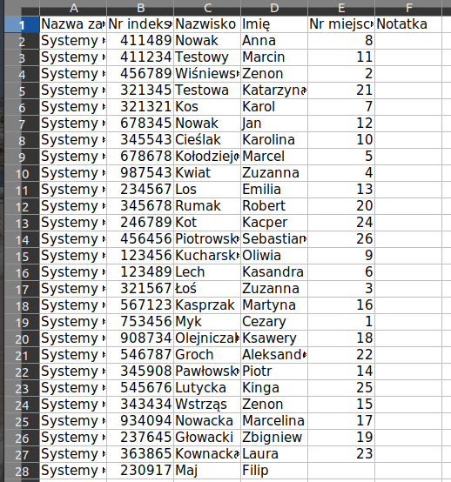

Figure 8. Attendance spredsheet

The first column identifies the class, the second is the student’s index number. Third and fourth column contain students’ surnames and forenames. The fifth column is the number of the seat taken by the student and the sixth column (empty at the screenshot) stores the teacher’s notes. Thanks to the knowledge of students’ seating the teacher can compare solutions and answers worked out by students sitting next to each other to prevent mutual copying.

The attendance at all classes may be also viewed in an edit window (Figure 9). The teacher may add a note (blue button) or delete an attendance (red button).

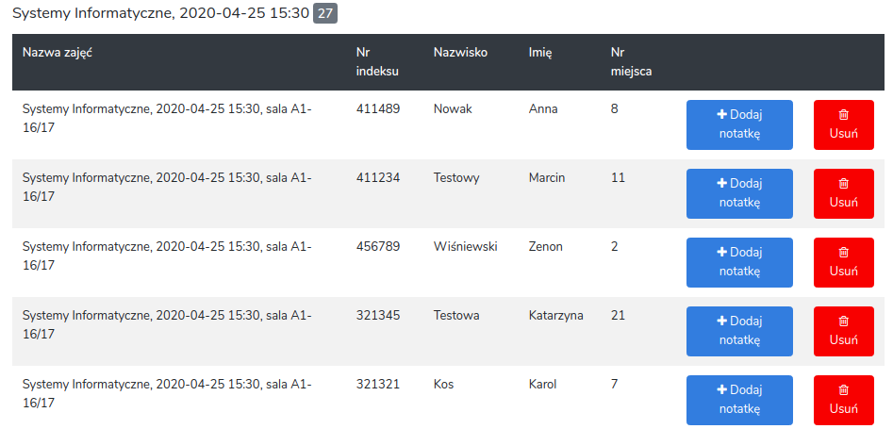

Figure 9. Attendance edit window

# Experiments and deployment

@CHECK has been successfully tested during a laboratory class and a lecture. The laboratory class was attended by 25 students sitting in two neighbouring classrooms, each having a different setting of students’ seats. The attendance client program was installed at one of the computers, standing near the entry to one of the classrooms. The attendance mode was set to “seating” and each student selected their seat after checking attendance. The system worked as expected.

The lecture was attended by 48 students. The @CHECK computer was located near the entry to the hall. The attendance mode was set to “automatic”. All students cards were properly recognized by the system.

At the beginning of the summer semester, which started on the 24th of February 20, six teachers of FMCS agreed to test the software at their classes. The number of courses to be tested was set to 10. The server version was installed at the faculty machine and the clients were installed at selected computers in the classrooms scheduled to host the courses. The Covid-19 virus epidemy abruptly broke the experiments.

One of the most important features of the solution is its scalability. The module processing student cards can be easily extended to support any type of a chip. As a matter of fact, three different types of student cards are currently in use at FMCS (depending on the date of issue) and all of them are successfully processed by the system. This makes us believe that adapting the system to other types of chips does not require much effort. The software supports use in other languages than the current one (Polish). New settings for classroom seats may be easily defined in the system.

# conclusions

The paper presents a tool for attendance check, worked out by the students of FMCS in the collaboration with their teachers. The solution resembles a swipe card system and has a few advantages over other methods used for the task.

## Time effectiveness

Comparing to standard procedures (e.g. verbal checking) @CHECK saves time spent during the class and teacher’s time spent between classes – for reporting and statistics.

## Low cost

The solution is low-costed. It requires no additional equipment at the FCMS; in case of deployment outside FMCS the cost for the additional equipment is ca one-time 10€ purchase per classroom (for the special keyboard or dedicated chip reader).

## Students’ privacy

Before each attendance check the teacher is required to input a verifying code. The students attendance is known only to the teacher.

## Cheating prevention

No system cannot be broken. Using @CHECK a student may confirm the attendance of the absent colleague with their borrowed student card. This, however, requires more “initiative” than just ticking the colleagues name in on-line solutions.

## Flexibility

The system may be used in various scenarios. The reporting and the statistics may be viewed by the teacher by means of systems edit windows or MS-Excel spreadsheets.

## Scalability

We believe that adapting the system to the needs of other schools would require little effort. Student chip cards apply similar formats. Even now, @CHECK successfully processes three different chip types.

The adaption for specific classrooms is not obligatory. A default classroom type is defined in the system by the number of rows and the number of seats in each row; most classroom setiings may be represented this way.

## Uniqueness

The system provides a unique feature – three seating modes, which may prove very helpful in teaching. The students are no longer anonymous to the teacher. The teacher can compare solutions and answers worked out by students sitting next to each other to prevent mutual copying. The teacher can also use the system to seat students randomly during test and exams.

It is worth noting that the whole system was invented, planned, documented and deployed by a group of four students (two students of computer science and two students of data analysis) within one semester lasting less than 4 months.

We strongly believe that the system may be easily adapted to serve academies all over the world.

References

1. “Attendance tracking – how to track and check attendance”, Accessed 26 April, 2020. Retrieved from <https://clockify.me/blog/business/tracking-checking-attendance/>
2. “MyAT's attendance tracking, student grading and parent messaging features”. Accessed 26 April 2020. Retrieved from https://www.myattendancetracker.com
3. Answers at Microsoft Community, Accessed 26 April, 2020. Retrieved from <https://answers.microsoft.com/en-us/education_ms/forum/all/how-to-record-attendance-in-microsoft-teams/28e6dfc1-4e86-4c7a-b4c2-cbd8b9047105>

1. Some methods described in Sections 2 and 3 are based on [1].
2. All the students’ names used in the screenshots are fictious.